**Looking For Quadcopter Motors, Where to Start?**

For quadcopters of all sizes, you should know what the frame size and weight of your copter are before choosing motors. However if you are just building a 5″ racing drone, you can jump straight to the [“Motor Size” section](https://oscarliang.com/quadcopter-motor-propeller/#frame-prop-motor-size).

If you are new to [mini quad and FPV](https://oscarliang.com/mini-quad-racing-guide/), please carry on reading.

There are Brushless and Brushed motors in RC. Generally we use Brushless motors on larger models, and Brushed on smaller ones. I will post another article explaining the differences in more detail in the future.

**What Is the Frame Size and Weight?**

The total weight of the quadcopter should include all the components you plan to take on-board: frame, FC, PDB, RX, VTX, antenna, motors, propellers, ESC’s, LiPo battery, additional payload such as the GoPro, and so on.

You probably won’t get it exact to the gram, and it’s better to overestimate the weight and have extra power than underestimate, and not be able to fly. Adding 10-20 grams to compensate for wires, buzzer, zip ties etc is also a good practice.

By knowing the frame size, you can determine the maximum propeller size allowed on your quadcopter. And once you have worked out the total weight of the craft, you can estimate what kind of thrust is required for the motor and propeller combination in order to lift the aircraft.

Further Reading: [how to choose propellers](https://oscarliang.com/choose-propellers-mini-quad/) for mini quad.

**Thrust to Weight Ratio**

A general rule is that you should be able to provide **at least** twice as much thrust as the total weight of the quadcopter. Remember this is the bare minimum to ensure you have a stable copter that is easy to control during hovering. If the thrust provided by the motors is too little, the copter will not respond well to your control, it might even have difficulty taking off.

*For example if we have a quadcopter that weighs 1Kg, the total thrust generated by the motors at 100% throttle should be at least 2Kg, or 500g per motor (for a quadcopter). Of course it’s always nice to have more thrust available than needed…*

For faster flying such as drone racing, you should expect the power to weight ratio to go **much higher** than this. It’s not uncommon to see someone build a mini quad that can achieve 10:1, or even 13:1 thrust to weight ratio. Generally speaking, for acro flying, I recommend to have at least 5:1.

With a higher thrust to weight ratio, a quadcopter will have better agility and acceleration. When thrust to weight ratio is too high, however, the quad can become very hard to control. Just a little touch of throttle will be enough to “shoot the quad into orbit like a rocket”. :D Of course this depends on the pilot skills too.

Even if you only just plan to fly a slow aerial photography platform, you should aim at somewhere between 3:1 and 4:1. This not only gives you better control, but also provides room for extra payload in the future. For example, heavier cameras or larger batteries for extended flight time. But if you are into racing, then there is no limit :D Go as high as you feel comfortable with!

**Motor Size Explained**

The Size of brushless motors in RC is normally indicated by a 4-digit number – AABB. “AA” is the **stator width** (or stator diameter) while “BB” is the **stator height**, both are measured in mm (millimeter).

*What is brushless motor stator? – A stator is the stationary part of the motor, this has ‘poles’, which are wrapped around by copper wires (windings). The ‘poles’ are made of many layers of thin metal plate that is laminated together with a very thin insulation layer in between.*

* Taller stator = more power at higher RPM
* Wider stator = more torque at lower RPM

Increasing the either the width or height of a motor will increase both the size of the permanent magnet and the electromagnetic stator coils. The main difference is, when increasing the **stator height, it increases the permanent magnet size** more than the coil size, and when increasing the **stator width, it increases the electromagnetic coil size** more than the permanent magnet.

[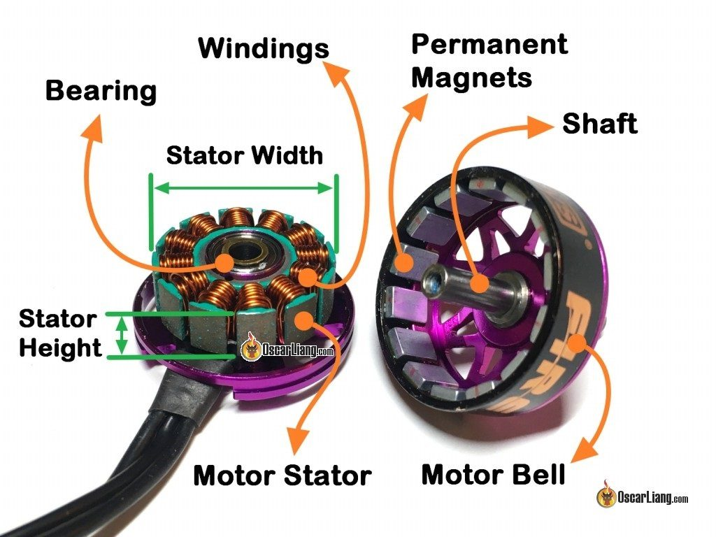](https://oscarliang.com/ctt/uploads/2017/12/mini-quad-brushless-motor-anatomy-bell-magnet-bearing-stator-winding-shaft-diagram.jpg)

The size of propellers a motor is designed for determines the prop shaft size. Motors for 3″, 4″, 5″ and 6″ propellers all have M5 (5mm diameter) motor shaft. Modern motors have the prop shaft integrated into the motor bell, while older generation motors might have separate [prop adapters](https://oscarliang.com/types-prop-adapter/).

Currently, common stator sizes for 5″ propellers are 2204, 2205, 2206, 2207, 2305, 2306, 2307, 2407.

**Taller Stator vs. Wider Stator**

Taller stator has a larger “area surface”, therefore it can cut through more magnetic field. The larger surface area also helps heat dissipation. Taller motors are known to be powerful and hold up at high RPM.

Wider stator motors have a larger volume of iron and copper in the stator, and are known to make a more torquey, and efficient motor.

**KV**

“KV” is a guideline of how many RPM a motor give up per volt. (For a [more academic explanation of KV](http://intofpv.com/t-kv-is-not-what-you-think-it-is))

It’s an important parameter of brushless motors, which indicates the theoretical increase of RPM (rotation per minute) when voltage goes up (without load, i.e. propeller). For example, when powering a 2300KV motor with a 3S LiPo battery (12.6V), it will spin at around 28980 RPM without props on (2300 x 12.6). Typically this is just a round up estimation specified by the manufacturer.

Once you mount a propeller on the motor, the RPM decreases drastically due to air resistance. Higher KV motors would attempt to spin the propeller faster, and it can draw more current. That’s why we tend to see larger props paired with low KV motors, while smaller and lighter props are better suited to high KV motors.

*The KV value can be determined by the number of copper wire windings on the stator. Generally the higher number of winds decreases the KV of the motor, while lower number of winds increases the KV.*

*The magnetic strength of the magnets can also affect the KV value, stronger magnets will increase KV.*

By pairing a high KV motor with an excessively large propeller, the motor will attempt to spin fast like it would with a smaller prop, but this will require more torque. As it tries to produce the required torque it will draw more current and subsequently generate too much heat. This will eventually lead to overheating and it can burn out the motor. This is because when the motor overheats, the coating on the coil will start melting and causing electrical shorts inside the motor.

*Generally speaking, heavier quad usually pair with medium to low KV motors, lighter quad usually use high KV motors.*

**Motor Torque**

Some say lower KV motors have higher torque, and higher KV motors have lower torque. While it’s possible, it’s not entirely true. KV has almost nothing to do with torque, but mainly affects the current and voltage limits of the motor.

As explained, higher KV motors have shorter windings and thus lower resistance. It lowers maximum voltage rating and increases the current draw for the motor and propeller combo, and not much else.

Torque is mainly defined by

* stator size: the bigger the more torque
* Materials: the type of magnets, quality of the copper windings
* Motor construction: things like air gap, number of poles etc

With everything being equal, two identical motors should have the same the torque theoretically even if one motor has a different KV. Lower KV just means you need higher voltage to get it to the same RPM (power). It’s a little more complicated than this of course, but this is a reasonable approximation.

One reason that people feel like low KV motors have more torque is the worse voltage sag with high KV motors, which kills the torque. In theory they’d have the same amount of torque, but they can’t in reality.

Torque is a double-edged sword.

High torque motors allows for more rapid change of RPM and faster response time, you will get less prop wash oscillation and it will give you that instant and snappy response. But high torque motors also feel sharper and more robotic, while lower torque motors generally feel smoother and softer. The choice depends on your flying style, and personal preference, and higher torque is not always better.

Nowadays, many pilots are troubled by oscillation problems more often than ever, and the issue can be traced back to the modern, high torque, high power motors. These are so powerful they can amplify the output, and create an oscillation feedback loop, which is very difficult to eliminate. Soft mounting your flight controller might just be enough to fix that, but we should try and eliminate that from the source and stay away from extremely powerful motors.

**Mounting Pattern**

Common motor patterns (hole distance) for22xx, 23xx, 24xx motors are 16x16mm and 16x19mm. Most 5″ frames should support these.

[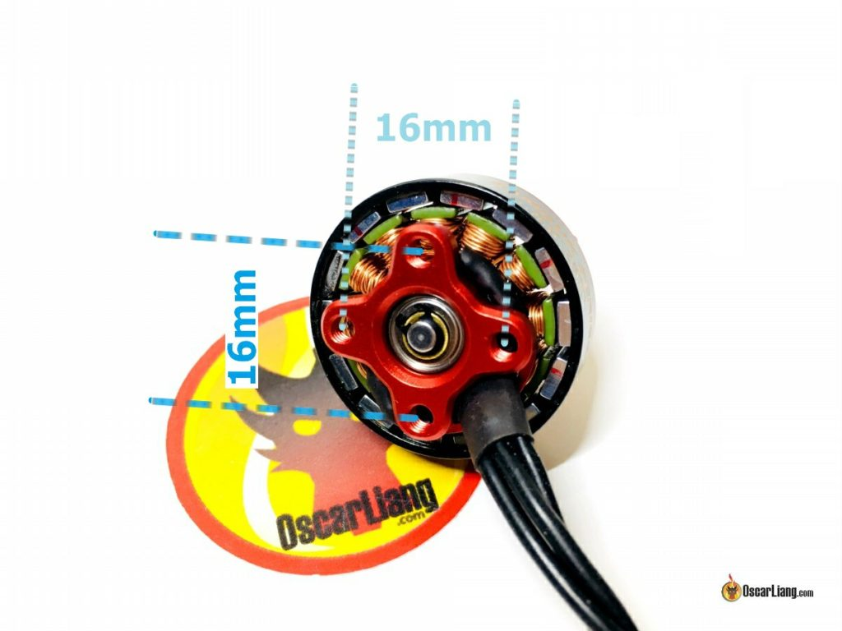](https://oscarliang.com/ctt/uploads/2017/12/racing-drone-mini-quad-motor-mounting-holes-pattern.jpg)

**N and P Numbers – Poles and Magnets**

You might have seen specification such as “12N14P” printed on the box of a motor. The number before the letter N means the number of electromagnets in the stator, i.e. poles, and the number before P means the number of permanent magnets in the bell.

[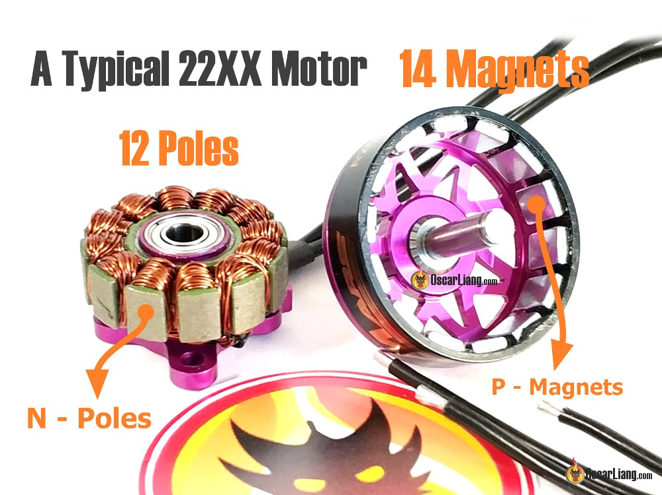](https://oscarliang.com/ctt/uploads/2017/12/quadcopter-brushless-motor-n-p-poles-magnets-number-12-14.jpg)

*Poles and Magnets in a Mini Quad Motor*

Different sizes motors have different number of poles, 22XX and 23XX motors generally have 12 poles and 14 magnets.

The number of poles determines the spacing between the poles if you have fewer poles, you can fill in more iron content in the stator, so you get more power out of the motor. But with a higher number of poles, the magnetic field is spreading out more evenly, and therefore you have a smoother running motor because you have a more fine controlled over the rotation of the bell.

* More poles = Smoother
* Fewer poles = More powerful

The pole configuration has to be a multiple of 3 because it’s a 3-phase motor and there are 3 wires into the motor, therefore the pole numbers have to be 9, 12, 15, 18 etc. That’s why the pole number is not easily changed, and thus it’s not an essential piece of information when picking motors especially for mini quad.

**Motor Windings**

The number of copper windings or ‘turns’ on a stator pole determines the maximum current a motor will draw, while the thickness of the wire determines how much current the motor can handle before overheating.

Fewer turns = less resistance = higher KV. The downside is a reduced electromagnetic field on the stator and thus lower torque.

The opposite happens when we have more turns in the coil. The increase of copper produces a larger magnetic field on the stator pole and generates more torque. But due to the longer wires and higher resistance, the KV of the motor decreases.

To tackle these issues when increasing the power of mini quad motors, manufacturers choose to increase the number of windings while using thicker copper wires.

This will effectively reduce the resistance in the winding, and improve the power without sacrificing efficiency and torque. The motor would also be able to handle high current without burning out with larger wire gauge.

However thicker wires and more windings means a heavier motor, and the winding takes up more physical space so it requires a larger stator. That’s why we are seeing more bigger and heavier motors, and that’s also why bigger motors are generally more powerful.

**Multi-Stranded vs. Single Stranded Windings**

Single stranded windings are thicker, therefore manage heat better and better suited for those who run higher voltages like 5S or 6S. But you cannot pack as many wires around the stator because the gaps are larger between the thicker wires.

Multi stranded windings use 3 smaller wires to replace the 1 thicker wire in single stranded windings. Due to the thinner wires, they don’t carry as much heat and they will break easier physically.

But generally multi-stranded windings provide better performance than single stranded windings because you can pack the wires more tightly around the stator thanks to the smaller gaps between wires, and this will give you stronger magnetic field and a more powerful and efficient motor.

Note that the neatness of winding is also important, not only aesthetically, but also electrically. If the winding is messy and has a lot of wire crossings, the wires doesn’t cross the stator perpendicularly and the resulted magnetic field will be less efficient.

**Bearing**

We don’t talk about bearing a lot in motor discussions, because there isn’t much info available, but I thought I should give you a basic introduction.

The size of the bearing is not the outer diameter or the inner diameter, but the difference between the outer and inner diameter. The wider it is the larger the marbles/balls it can fit inside it. Larger balls can take more abuse to break, hold up better to a crash. But smaller balls are more stable and smoother at high speed/RPM.

You have probably heard about motors using “Ceramic Bearings”? They use ceramic balls instead of metal balls, and they are indeed smoother, but easier to break.

The diameter of the hole in the bearing (inner diameter) also determines how big a shaft you can use.

**How to Decide on Motor Size?**

You can find out the component sizes to use in this order: **Frame Size** => **Prop Size** => **Motor Size**

By knowing the frame size, we can estimate what motor size we should use. Frame size limits props size, and each prop size requires a different motor RPM to generate thrust efficiently, this is where motor KV comes in.

You also have to make sure that the motors produce enough torque to spin your choice of propeller, this is where your stator size comes into play. Generally bigger stator size and higher KV means more current draw.

This table below is a general guideline, it’s not a hard-set rule, you might also see people using slightly higher or lower KV motors than this table suggests.

It assumes you are powering the quad with 4S LiPo batteries, and frame size is referring to the wheelbase (aka diagonal motor to motor distance).

|  |  |  |  |
| --- | --- | --- | --- |
| **Frame Size** | **Prop Size** | **Motor Size** | **KV** |
| 150mm or smaller | 3″ or smaller | 1105 -1306 or smaller | 3000KV or higher |
| 180mm | 4″ | 1806 | 2600KV – 3000KV |
| 210mm | 5″ | 2204-2208, 2306 | 2300KV-2600KV |
| 250mm | 6″ | 2204-2208, 2306 | 2000KV-2300KV |
| 350mm | 7″ | 2208 | 1600KV |
| 450mm | 8″, 9″, 10″ or larger | 2212 or larger | 1000KV or lower |

**Voltage and Current Draw**

It’s important to understand that voltage has a large impact on your motor and propeller choice. Your motor will try to spin faster with a higher voltage, thus draw a higher current. Ensure you are aware of how much thrust your motors produce and how much current they will draw.

When you know the current draw of the the motor and prop combination, you are now ready to [choose ESC for your drone](https://oscarliang.com/choose-esc-racing-drones/).

**Basic Measurements of Motor Performance**

Once you have decided on motor size, you probably still have many options available to choose from. To pick the best motor for your application, you can consider the following factors:

* Thrust
* Efficiency and Current Draw
* Weight

The decision here really depends on your application, flying style, and how you want your aircraft to perform.

**Thrust**

Thrust is probably the first thing people look at when choosing a motor.

Higher thrust gives you faster acceleration, but you also need to be aware of current draw and efficiency. Don’t abuse your batteries with an amperage-hungry motor/prop combo.

If your quad draws a lot of current at high throttle, [the maximum discharge rate](https://oscarliang.com/lipo-battery-c-rating/) of your battery has to be able to keep up. The battery must also have a large enough capacity to ensure acceptable flight time.

While thrust is an important aspect in selecting a motor, it’s not the only thing to consider.

**Motor Weight**

The weight of a motor often gets overlooked, which can be a very important factor for acrobatics and racing drones.

Since the motors are mounted at the four corners of the frame, they have a strong influence on the responsiveness of your quad. Heavier motors increase the angular moment of inertia of your quad, the motors must work harder in order to change attitude.

In practice, when your quad is doing flips and rolls, it takes time to pick up angular acceleration, move to the desired position and stop. Heavier motors will take longer to pick up that angular speed, and also longer to slow down. That’s why it feels less responsive.

**Efficiency and Current Draw**

Motor efficiency is typically calculated by dividing thrust by power at 100% throttle, measured in grams per watt (g/w). The higher this number is, the more efficient the motor.

It’s important to look at efficiency through the whole throttle range, not just the top end. Some motors might be efficient at lower throttle, but could lose efficiency by drawing increasingly higher current as they approach their limits.

Another good way to look at efficiency is to use “grams per amp” (thrust/current).

Generally, the more thrust generated, the larger the current drawn to produce that thrust, so motors with high thrust and low current are preferred. Inefficient motors either generate too little thrust or draw too much current.

Every motor responds differently to different propellers, carefully choosing your propeller is the key to balance thrust and efficiency.

**Advance Quadcopter Motor Performance Factors**

Many quadcopter motor properties are not mentioned by the manufacturers and can only be found through more technical testing.

* Torque
* Response Time
* Temperature
* Vibration and balance

**Motor Torque**

Torque is the force that turns the propeller, it determines how fast a motor can increase and decrease RPM. In other words, how easy it is for the motor to move the mass of the rotor, prop, and most importantly, the air.

Torque greatly affects the performance of your quad, specifically, how precise and responsive it feels in flight. A motor with high torque gives more snappy response, because of the faster change of RPM. You might even experience less prop wash with more torque.

High torque also means you can run heavier props (at the cost of drawing more current). If a low torque motor is driving a propeller that is too heavy for it (aka over-prop), the motor will be unable to produce enough force to spin it at the desired RPM, resulting in poor efficiency and overheating.

One drawback of high torque motors though, is oscillation. Motors with high torque are able to change RPM so rapidly that it can actually amplify [error (in PID loop)](https://oscarliang.com/quadcopter-pid-explained-tuning/), causing oscillation that can be hard to eliminate even with PID tuning, [especially on the yaw axis](https://oscarliang.com/types-of-multicopter/).

**Response Time**

Motor Response Time is also dependent on torque, high torque motors often have faster response time. One easy way to measure response time is to see how long it takes for a motor to reach maximum RPM from 0.

Response time will be affected largely by the weight and pitch of your propeller choice. Remember that atmospheric conditions can have an effect too. At low altitude, for example, the air is thicker, this means that there is a greater number of air molecules that the propeller must physically move, to produce thrust. At high altitude, your props will spin faster and react quicker to changes in throttle, but the overall thrust will be reduced, because there are fewer air molecules for the prop to interact with.

**Temperature**

Temperature affects brushless motors because the magnets used in our motors have a weaker magnetic field when operating at high temperature, they also demagnetize faster at the motor gets too hot which affects lifespan.

Over-propping your motors and using full throttle excessively, will cause your motors to run hot. This will degrade the performance of the motor and the magnets over time, therefore motor designs which aid cooling often equates to a longer lifespan. That is of course, provided you don’t destroy it in a crash beforehand!

**Vibration**

Vibration caused by the motors can have a number of unpleasant side effects to the performance of your quad.

If a motor has poor balance or build quality, you might experience vibration that can affect your PID controller. As the frequency of the vibration changes at different throttle levels, this can make your quad very difficult to tune.

A motor suffering from vibration will also produce a greater amount of electrical noise than one which is running smoothly. This electrical noise can affect your Gyro sensor, making flight performance even worse, and it will also degrade your FPV video quality if you are powering your FPV system from the same battery as the motors and ESC’s.

Many have successfully [soft mounted motors, and the flight controller](https://oscarliang.com/soft-mounting-fc-motors/) to reduce vibration, with some really positive results.

Remember that damaged, bent and unbalanced propellers can also cause problematic vibrations.

**Features in Mini Quad Motor**

There are so many variables that affect the performance of a motor, it can get very controversial and complicated. For example, motors with the same stator size and KV, you can have very different thrust, current draw and response time even using the same prop. Differences in the design and material both have a great impact on performance.

Here I will explain a few different motor design features that contributes to better performance, which can also change the characteristics of the motor.

**Motor Shaft**

The construction of motor shaft is changing over time. It used to be a solid aluminium rod, later manufacturers start using hollow shaft with titanium. Similar weight but much stiffer and harder to bend. However drilling the hole in the middle of the titanium shaft increases the cost of manufacturing significantly.

And more recently they’ve come up with a new motor shaft design, by inserting a steel rod in the hollow shaft for the extra strength.

[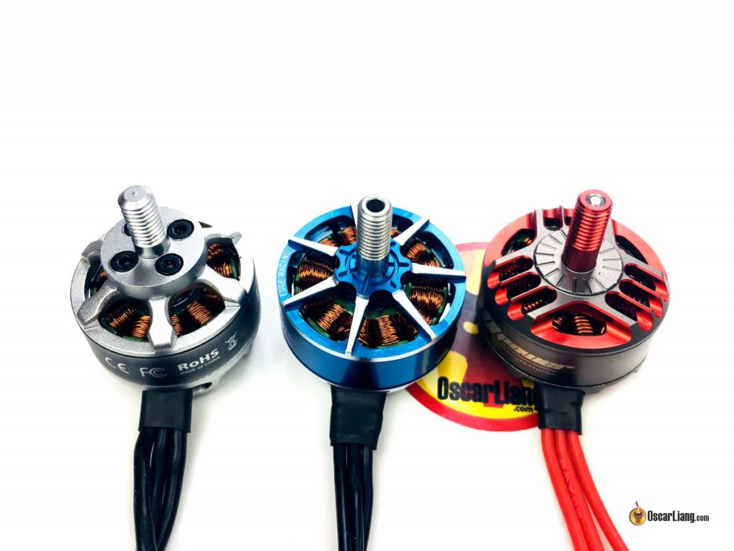](https://oscarliang.com/ctt/uploads/2018/04/RCINPower-Mark1-2306-Motor-prop-shaft.jpg)

**Brushless Motor Magnets**

Magnets used in brushless motors are graded according to their magnetic field strength, such as N52, N54 etc. The higher the number, the stronger the magnetic field.

A stronger magnetic field is theoretically capable of generating power more efficiently, providing more torque and a faster motor response time.

When you turn a motor by hand, you can feel the notches, the stronger you can feel them is actually a bad thing because it tells you how strong the magnetic force is, and how weak it is in between magnets, which tells you the magnetic field is not even. Weaker notches usually means a smoother motor.

Magnets will lose magnetic strength when they reach certain temperature, therefore N52H is used to prevent this problem. The letter at the end has to do with operating temperature. It’s said that N52SH can withstand even higher temperature, but there is no data at the moment to indicate how much better N52SH is compared to N52H and N52.

It’s possible that magnets get loose in crashes or due to vibration. You can glue it back in the bell using Loctit 438.

**Stator lamination thickness**

A lamination is the thickness of the individual sheets of metal stacked up in the motor stator, thinner lamination allows you to stack more layers of stator plates for the same height of the motor stator.

In a nutshell, the thinner stator lamination, the better. Laminations help to reduce a phenomenon known as Eddy Current, which generate heat in a changing magnetic environment. Thinner laminiations means less power is wasted on generating the eddy currents (leads to undesired magnetic field) and making motors more powerful and efficient.

[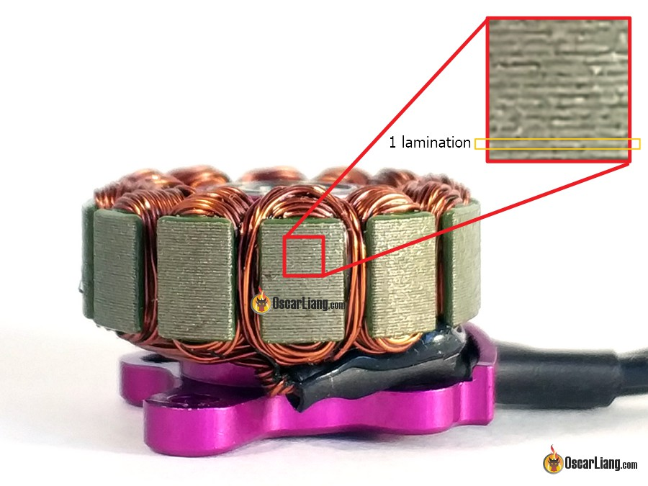](https://oscarliang.com/ctt/uploads/2017/12/quadcopter-brushless-motor-stator-lamination-layer.jpg)

*Motor Stator Lamination*

**Air Gap**

“Air gap” in a motor refers to the distance between the permanent magnets and the stator. Magnetic force degrades non-linearly with distance, so reducing the gap between the two significantly boosts the power of the motor.

A smaller air gap not only makes the motor more powerful, it also improves torque and response. The downside of tighter airgap is the increase in current draw and decrease in efficiency. Also there is concern regarding durability, if the motor bell takes any sort of impact and it gets out of alignment and shifted at all, the magnet can run into the stator and end up getting shattered.

**Magnet Shape – Arc Magnets**

Using arc magnets (aka curved magnets), is a technique to bring the magnets even closer to the stator; allows for a smaller and more consistent air gap.

In fact, the way a permanent magnetic field works means that with a curved magnet, the strongest magnetic point of each pole is no longer on the surface of the magnet, as it is with standard (non arc) magnets.

The ‘epicentre’ of the field of the pole on the outside of the curve, will be below the surface of the magnet, and the epicentre of the pole on the inner curve will actually be above the surface. In this manner, the magnetic fields of the permanent and electromagnets are actually brought even closer together, over and above the physical reduction of the air gap.

Apart from the shape, some manufacturers test mini quad motors with different thicknesses of magnet, often finding that a slightly thinner magnet (therefore a weaker magnetic field) can actually provide better results.

**C-Clip / E-Clip / Screw Shaft**

To hold the motor bell to the base, motor manufacturers use one of these methods on the bottom of the motor to lock the shaft in place: C-clip, E-clip or a screw. Each of these ways has their pros and cons, and it’s hard to say which one is the best.

[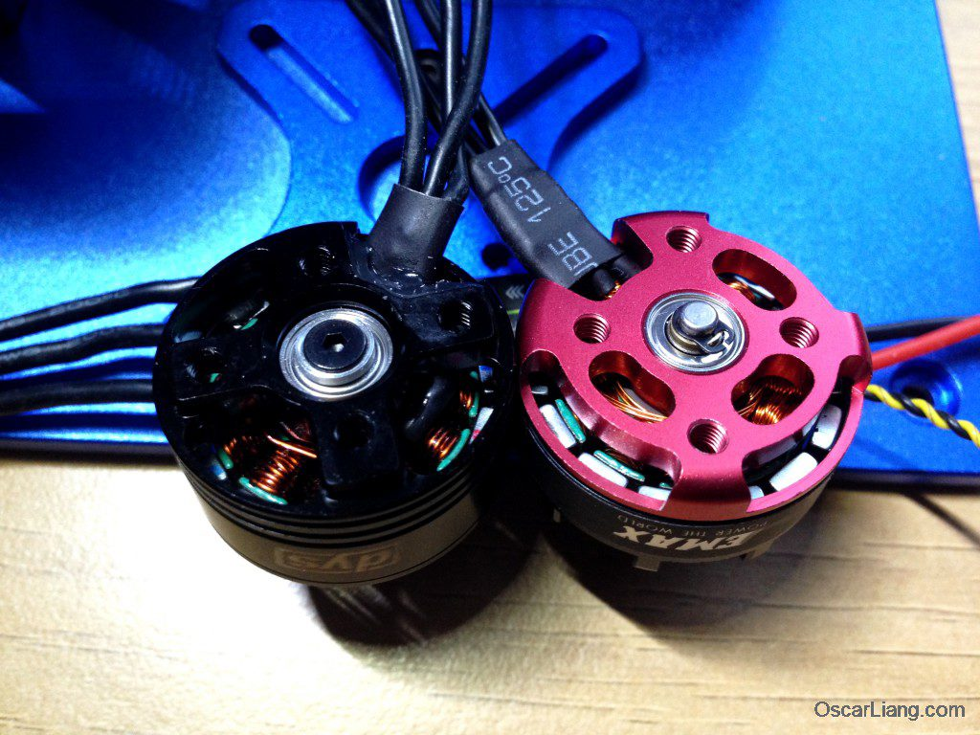](https://oscarliang.com/ctt/uploads/2016/04/dys-se2205-2300kv-motor-mini-quad-bottom-shaft-rs2205-c-clip-screw.jpg)

*C-Clip vs. Screw on the bottom of a Motor Shaft*

Generally speaking, screws are better for user maintenance as it’s easier to remove a screw than a C-clip or E-clip. But screws suffer from risk of over-tightening and locking the shaft (making the motor harder to spin).

There are reports about C-clips popping off during flight, which resulting the motor bell flying off and causing a crash. However, be aware that screws are also not immune to this problem.

**Naked bottom or closed bottom?**

In motor base design, there is the more traditional “closed bottom” approach, and the more recent “naked bottom” style. There are pros and cons to both of these designs.

[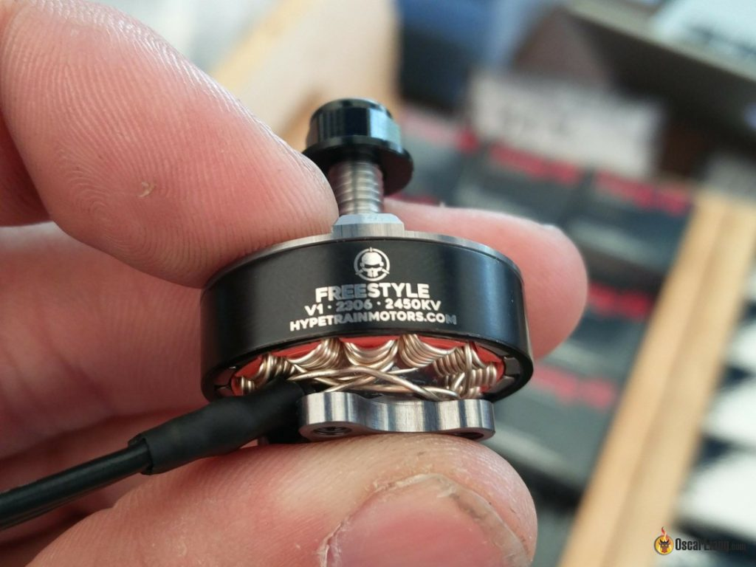](https://oscarliang.com/ctt/uploads/2017/05/mini-quad-motor-naked-bottom-open-motor-base-design.jpg)

*Motor with Naked Bottom (Open Motor Base)*

[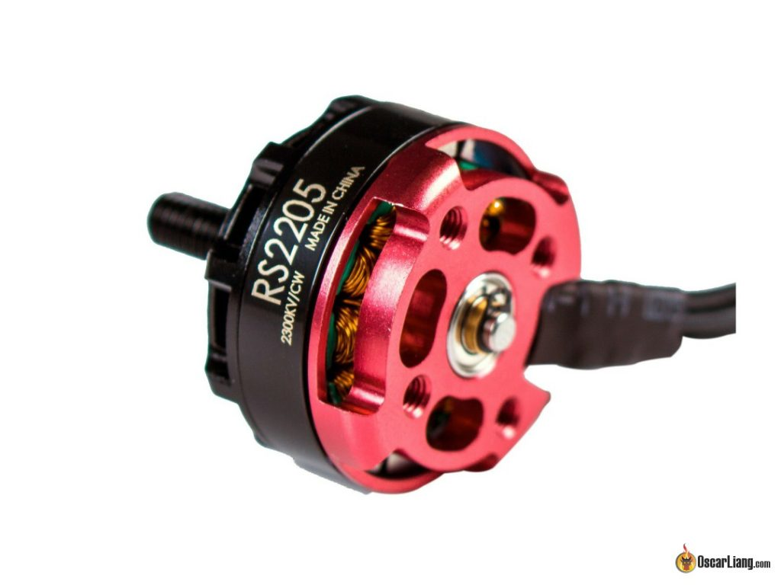](https://oscarliang.com/ctt/uploads/2017/05/mini-quad-motor-closed-bottom-skirt-motor-base-design.jpg)

*Motor with closed bottom*

The “closed bottom” design means a stronger base, however the “naked bottom” tend to be lighter by removing the excess material, the weight saving is around 2g.

Closed base motors are less likely to get dirt trapped inside the bell, against the argument that, naked bottom are easier to clean the dirt out.

With naked bottom, you can see clearly how far the screws are going in, and you have less chance of [shorting the motor winding if the screws are too long](https://oscarliang.com/check-motor-screws-touching-winding/). (This happens often to beginners with closed bottom motors.)

[](https://oscarliang.com/ctt/uploads/2017/12/motor-naked-bottom-open-dirt-get-in.jpg)

*Naked bottom motors are easy to get dirt inside the motor, but it’s also easier to clean*

However, the closed bottom provides better strain relief to the wires in case of crashing and stretching.

**Flux Ring Design**

A flux ring is the round steel ring inside the bell that contains the magnets. The bell is usually made of aluminium, while the flux ring is made of steel because it has to respond to magnetic field lines.

The latest flux ring design is a custom shape instead of the usual round shape, which can help direct more magnetic field lines back into the motor and improve the torque.

**PoPo Shaft Technology**

The “Pop on Pop off” system is basically a motor shaft with spring loaded bearing for installing and removing props quickly. For a [more detail overview and product list check out this article](https://oscarliang.com/popo-motors-propellers/).

[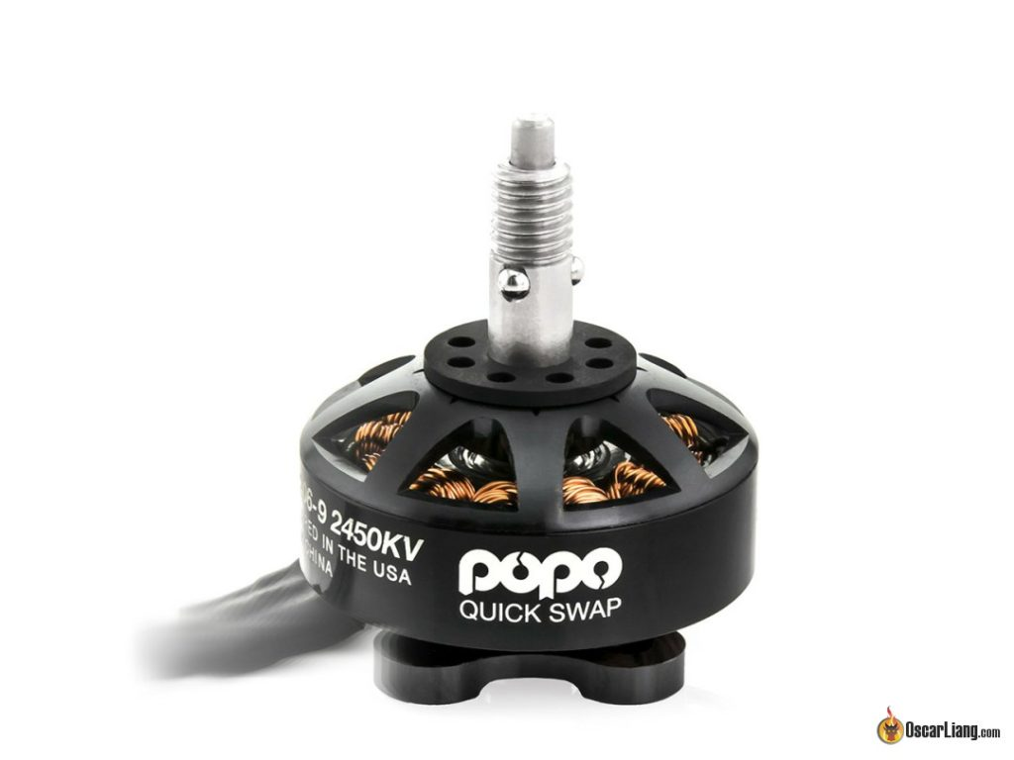](https://oscarliang.com/ctt/uploads/2018/09/popo-pop-on-pop-off-quick-swap-system-motor.jpg)

**Other Features**

* Soldering tabs
* ESC integration
* Cooling design

Motor manufacturers are constantly experimenting with different designs and levels of hardware integration, which has led to advances in cooling and even integrating ESC inside the motor. Personally I think solder tabs on the motor can come in handy, it allows you to use a lighter gauge wire to save weight on less amp hungry applications. They should also be easily repairable if the wires get pulled off, which can often spell the end of a motor of typical design.

**CW and CCW Motors**

You will sometimes see brushless motors labelled as CW and CCW. They stand for “ClockWise” and “Counter-ClockWise”.

While this is important for brushed motors because the brushes wear out quicker when rotating in the wrong direction, brushless motors are not limited in this way.

CW and CCW brushless motors are essentially the same motor that can spin both directions. The only difference is [the direction that the prop shaft is threaded](https://oscarliang.com/propeller-shaft-adapter-nuts-cw-ccw/).

The motors on a quad spin in different directions, the intention here is when the motors spin, all four prop nuts get tightened.

*To tell if you have the correct threaded motor on, simply hold the prop nut on the shaft, then start turning the motor with your hand in the direction it should spin. If the nut tightens then you have the correct one :)*

Personally I prefer to have the same threads on all my motors, so I don’t confuse myself with the different prop nuts. If you have to replace a prop nut at the hardware store, it can be a real headache trying to find a CCW threaded locknut  (or more commonly in the hardware jargon, a ‘left hand thread nut’).

**Balancing Motor**

When you receive your motors, the first thing to do is balance them. Although **it’s not always necessary**, it’s a good practice. I personally [only do this on large motors though such as 2212 or bigger](https://www.youtube.com/watch?v=nPY9etsSgjk).

I find balancing unnecessary for many brand name mini quad motors because the quality is generally good enough. However with cheaper options that are becoming available don’t be surprised to find less attention paid to quality control.